**Bracelets by Haley**

*Haley Potvin*

*10/7/2024*

*Marissa Cleroux*

*Assignment 1*

**Company name:** Bracelets by Haley

**What they do:** They make handmade bracelets using all sorts of different materials; beads, string, etc. so that anyone will be able to find something they like.

**What the website is for:** The website is there to sell the bracelets online and give users and customers more insight into what this company does.

**Pages the website will have:**

*Home*

page describing the site. It will also contain the hours of operation and a video about the business.

*Products*

A page dedicated to buying merchandise. This will include; products and their prices and any special deals may be going on during that time.

*Related*

A page containing links to related websites. For example; businesses that sell the products we use to make the bracelets, videos showing tutorials on how to make your own bracelets at home.

*Contact us*

An inquiry and contact us page containing a form that the user can fill in. The form may ask questions such as; what patterns would you like to see for bracelets? What could we do to improve our business? Etc.

*Staff*

A page containing photos of staff members and the team. These will include pictures of people in each department; head bracelet makers, chief of website design, etc.

**The target audience:** Thetarget audience is anyone since we would like to appeal to the most people at once, but ifthey were to narrow it down it would be targeted towards mostly older kids and teenagers (between 8-16) because of the bring and fun colours that they tend to be drawn towards. A reason why younger kids aren’t included despite liking bright colours as well is because some pieces may be small and could be a choking hazard.

**The logo:**

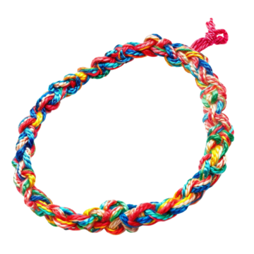

I got this logo from a website called Pngtree, this image is licensable

**The colour palette:**

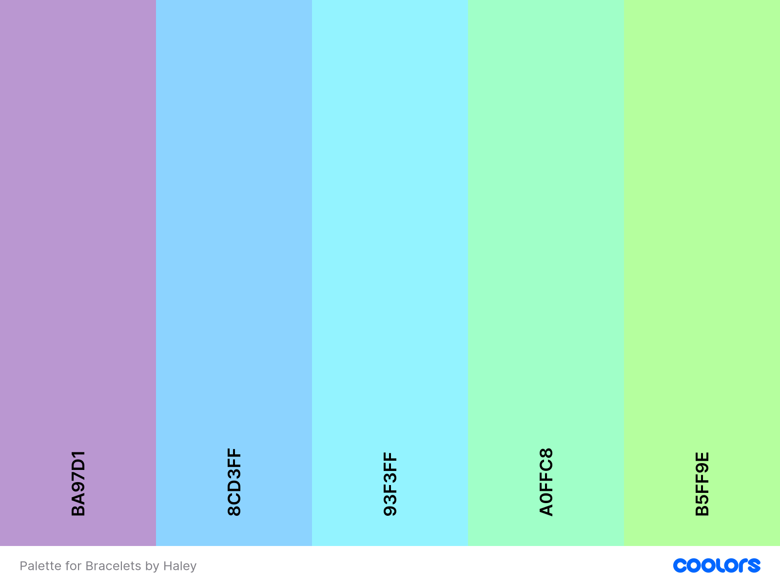

**The banner:**

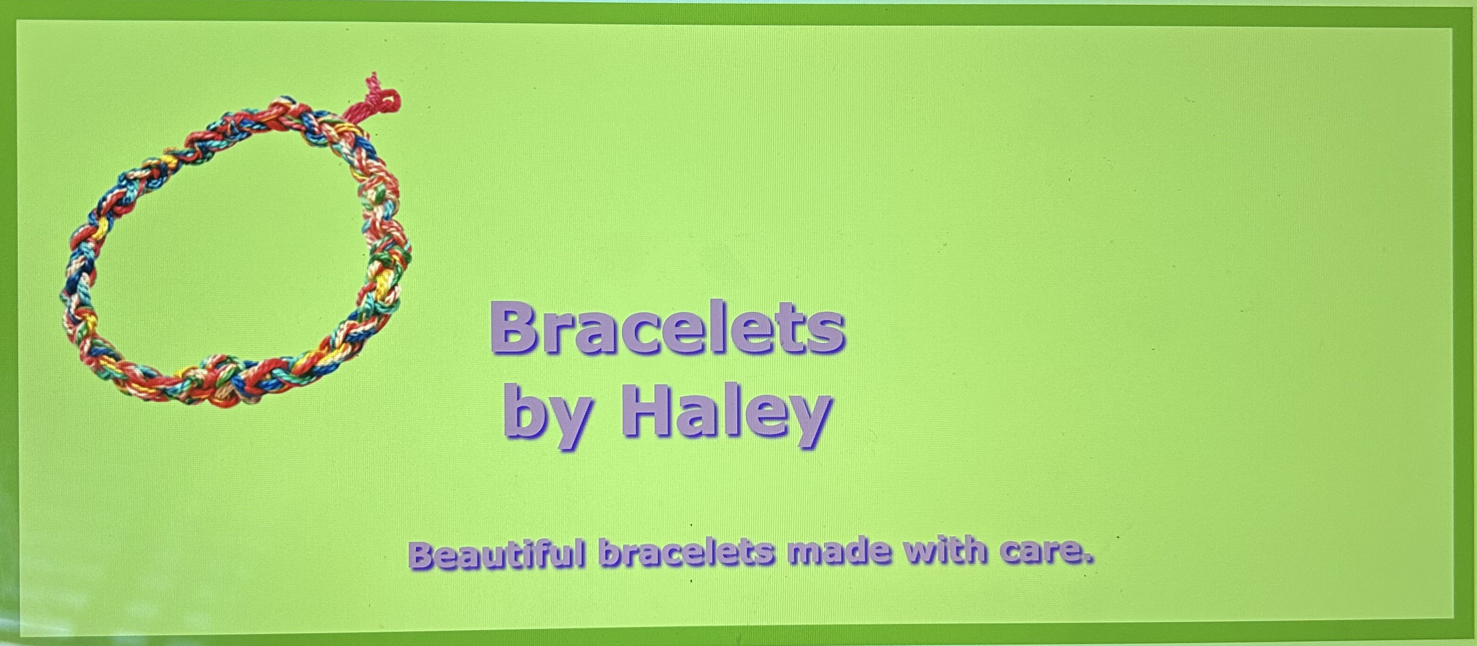

**The mobile mock-up:**

**The desktop mock-up:**